# CHAPTER 1

**Introduction**

Internet is considered as a major storehouse of information in today’s world. No single work can be done without help. It has become one of the major ways of communication. Out of all communication methods available, Social Media is one of the most common forms. Social media has changed the world. The number of internet users worldwide in 2019 is 4.388 billion, up 9.1% year-on-year. The number of social media users worldwide in 2019 is 3.484 billion, up 9% year-on-year. Social media has been blamed for promoting social ills. People have a need to fit in to be visible praised in this new digital world. Social Media has many ill effects such as Cyber-bullying, Harassment and Depression. Evidence is mounting that there is a link between social media and [depression.](https://childmind.org/topics/concerns/depression/) It is an almost undisputable truth that access to a cloak of anonymity and a large, large microphone brings the worst out in some people. Today, this is particularly true on social media. Online harassment and hate- messaging is a [growing trend](http://www.huffingtonpost.com/craig-newmark/new-study-reveals-drastic_b_11321304.html) and a growing security concern for anyone on social media today. In fact, [40% of Internet users](http://www.hackharassment.com/) say they have personally experienced online harassment. Researchers have found that the longer you spend on social media, the more likely you are to be depressed. Hence we have come up with this project in which we will be developing a system that helps in detecting a depressive and harassment text. The user of this system will not have to login or do any registration. The user simply has to put the textual post in the form and submit. On submitting the post the system will detect whether the post is depressive or harassment or neither.

In December 10, 2018 Gigen Mammoser wrote How Social Media Increases Depression and Loneliness in which he revealed how social media platforms like Facebook can greatly affect your mental health. Social media use can harm your mental health, especially when it’s used more frequently. Getty Images No matter what you did today on your phone or computer, it’s likely that social media was involved. In the United States today, you’re statistically more likely to use social media than not — by a lot. Approximately 77 percent of all Americans have a social media profile of some kind.Despite the popularity of social media platforms and the rapidity with which they’ve inserted themselves into nearly all facets of our lives, there’s a remarkable lack of clear data about how they affect us personally: our behaviors, our social relationships, and our mental health.

In many cases, the information that’s available isn’t pretty.Studies have linked the use of social media to depression, anxiety, poorer sleep quality, lower self-esteem, inattention, and hyperactivity — often in teens and adolescents.The list goes on.However, these studies are almost entirely of an observational or correlational nature, meaning they don’t establish whether or not one is causing the other. A common argument against the theory that social media makes individuals more depressed and lonely is simply that perhaps those who are more depressed and lonely are more inclined to use social media as a way of reaching out.

A new study concludes that there is in fact a causal link between the use of social media and negative effects on well-being, primarily depression and loneliness. The study was published in the Journal of Social and Clinical Psychology.“What we found overall is that if you use less social media, you are actually less depressed and less lonely, meaning that the decreased social media use is what causes that qualitative shift in your well-being,” said Jordyn Young, a co-author of the paper and a senior at the University of Pennsylvania.“Prior to this, all we could say was that there is an association between using social media and having poor outcomes with well-being,” she said.The researchers say this is the first time a causal link has ever been established in scientific research.The study included 143 students from the University of Pennsylvania. They were randomly assigned to one of two groups: one that would continue their social media habits as usual or one that would significantly limit access to social media.For three weeks, the experimental group had their social media use reduced to 30 minutes per day — 10 minutes on three different platforms (Facebook, Instagram, and Snapchat).

In order to keep these experimental conditions, the researchers looked at phone usage data, which documented how much time was spent using each app per day. All of the study participants had to use iPhones

# CHAPTER 2

**Literature Survey**

**2.1 Existing Systems**

Natural Language Processing (NLP) strategies to create an algorithm for Thai language depression diagnosis on Facebook where people use it as a platform for expressing thoughts, emotions and life events. Tests of 35 Facebook users showed Facebook habits could predict the degree of depression. [1]

Classification challenge and explores the efficacy of deep learning in identifying online abuse in a broad human-labeled dataset designed specifically for the purpose of abuse analysis. Types are considered for this reason, including Long Short-Term Memory (LSTM), Bidirectional Long Short- Term Memory (BLSTM), Convolutional Neural Network (CNN), and contrasted with other types. [2]

Cyberbullying is a crime in which an perpetrator bullies a victim who is being abused and disliked online. Some solutions to cyberbullying prevention were developed but they were mostly focused on textual and interface interfaces. The bulk of the literature work aimed at enhancing the identification by adding new apps. Though the extraction and selection processes of the app get tougher as the number of features increases. However, another downside to these enhancements is that it is easy to produce such features-for example, user age-. In this paper authors suggest automated identification of Twitter cyberbullying based on the very complex techniques of ML's deep-learning area. [3]

An increasing number of people suffering from mental health conditions resort to online resources (specialized websites, social media, etc.) to share their feelings. Early depression detection using social media data through deep learning models can help to change life trajectories and save lives. But the accuracy of these models was not satisfying due to the real-world imbalanced data distributions. To tackle this problem, we propose a deep learning model (X-A-BiLSTM) for depression detection in imbalanced social media data. To tackle this problem, authors are proposing a deep learning model (X- A-BiLSTM) to detect depression in imbalanced social media data. The X-A-BiLSTM architecture consists of two important components: the first is XGBoost, which is used to minimize data imbalance; and the second is a neural network Attention-BiLSTM, which enhances recognition functionality. The Reddit Self-reported Depression Diagnosis (RSDD) dataset was chosen, which contained approximately 9,000 users who believed to have been diagnosed with depression ("diagnosed people" and approximately 107,000 matched control people. Results indicate that our methodology greatly outperforms the existing state-of-the-art models on the RSDD dataset. [4]

Cyberbullying has emerged as a serious societal and public health problem that demands accurate methods for the detection of cyber-bullying instances in an effort to mitigate the consequences. While techniques to automatically detect cyberbullying incidents have been developed, the scalability and timeliness of existing cyberbullying detection approaches have largely been ignored. Authors resolve the void by formulating cyberbullying prevention as a question of serial hypothesis testing. Depending on this hypothesis, authors are suggesting a novel algorithm designed to minimize the time taken to lift a cyberbullying warning by dramatically reducing the amount of feature tests available to make a decision. Authors demonstrate the effectiveness of our approach using a real-world dataset from Twitter, one of the top five networks with the highest percentage of users reporting cyberbullying instances. Authors show that our approach is highly scalable while not sacrificing accuracy for scalability.

## 2.2 Limitation of Existing System

#### 2.2.1 MoodPath: ADepression

The System is not based on textual data that helps to identify mood and mental health but rather based on question and answer system.Also the system also takes 14 day to form an analysis and get results.

#### 2.2.2 Youper

Youper is chatbot based system hence the system only gets information about the questions being asked and it is more of mood tracker rather than depression or harassment detection

#### My MobileWatchDog

Although blocking a specific website is simple and receiving an warning should your child attempt to access anything banned, the filtering capabilities of My Smartphone Watchdog aren't very sophisticated. You can not filter domain categories; you need to block pages one by one, instead. The location features had been deceptive. Although blocking a certain website is simple and getting an warning should your child attempt to access anything banned, the filtering capabilities of My Smartphone Watchdog aren't very sophisticated. You can not filter domain categories; you have to block pages one by one, instead. The location features is deceiving.

#### Cyber Patrol Online Management

No remote management or notification features. Clever kids can beat time scheduler and IMfilter.

IM filter may block harmless words.

#### 2.2.5 Facebook Social Media for Depression Detection in the ThaiCommunity

Facebook has limited the data extraction process because they keep the user data private. This was the main limitation as the more the data the better is the results obtained on deep learning models.

#### 2.2.6 Deep learning for online harassment detection intweets

It is ruled out to be used in future due to the private information of large human labelled corpus.

#### 2.2.7 Optimized Twitter Cyberbullying Detection based on Deep Learning

It is basically limited to the tweet based information and it doesn’t extract feature from the tweet that are fed to them by classifier.

#### 2.2.8 Optimal Online Cyberbullying Detection

Limited due to advanced features and it’s use due to the scalability and timeliness of the existing cyber-bullying detection approaches.

## Objectives

The proposed system aims at providing automation for detecting depression and harassment on social media platforms. The system will assist the authorities with certain features added in tackling the problem of depression and harassment that is going on in social media through alerts.

## Problem Statement

Due to lack of proper systems for detecting depression and harassment, people nowadays are harassed on social media. People expression depression are also not identified and hence they get lonelier and worse. The prime impediment of implementing a Depression and Harassment Detection on Social Media System is the social and psychological help of the individuals themselves.

# CHAPTER 3

**Proposed System**

## LSTM

Long Short-Term Memory (LSTM) is an artificial neural recurrent network (RNN) architecture that is used in deep learning. LSTM has feedback relations as opposed to normal feedforward neural networks. It can process not only single data points (such as images), but also whole data sequences (such as voice or video). For example, LSTM refers to tasks such as unsegmented recognition of speech by linked handwriting recognition and anomaly detection in network traffic or IDS's (intrusion detection systems).

A typical LSTM unit consists of a cell, an input gate, an output gate and an oblivion gate. The cell recalls values over unpredictable periods of time, and the three gates control information flow into and out of the cell. LSTM networks are well adapted for classifying, storing, and making forecasts based on time series data, since there can be lags of uncertain length in a time series between significant events. LSTMs have been developed to deal with the issue of vanishing gradients that can be found while training conventional RNNs. Relative gap-length insensitivity is an advantage of LSTM over RNNs, hidden Markov models and other sequence-learning methods in many applications.[6]

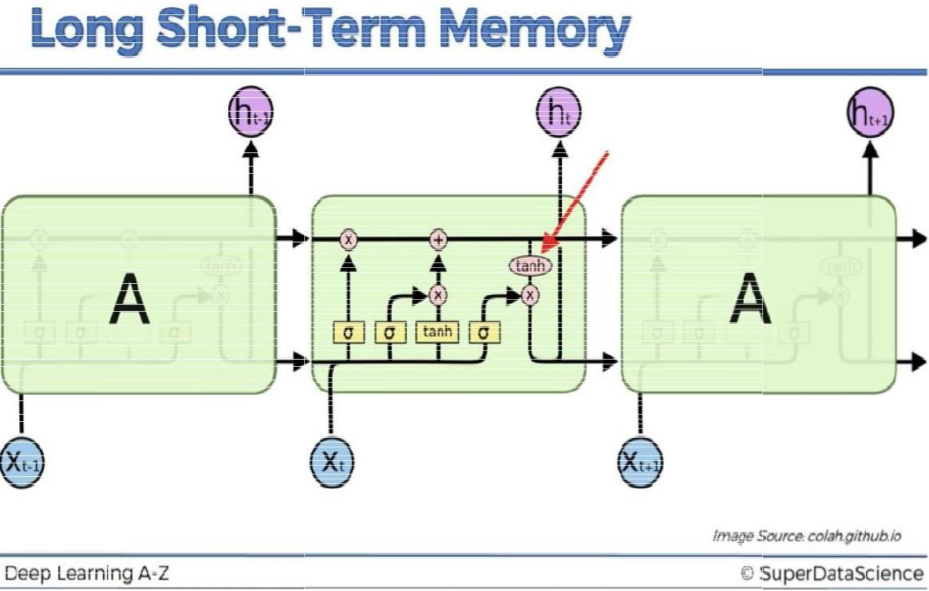

**[7]**

**Fig 3.1.1 Architecture of LSTM.**

## Details of Hardware & Softwares used

**Table 3.2.1 Modules developed**

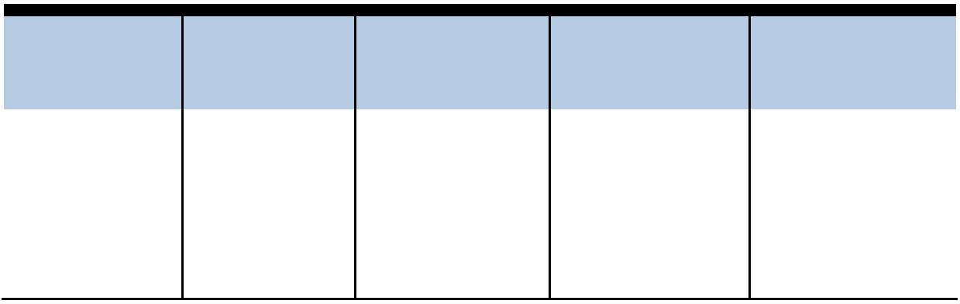

Collection

8GB+RAM,

Intel i3, i3+ processor.

Kaggle

formation.

|  |  |  |  |  |
| --- | --- | --- | --- | --- |
| **Modules & Sub-systems** | **Hardware Requirements** | **Software / Libraries** | **Technology** | **Application** |
|  |  | **Requirements** |  |  |
| Data | 8GB, | Python, Twint, | Scrapping | Dataset |

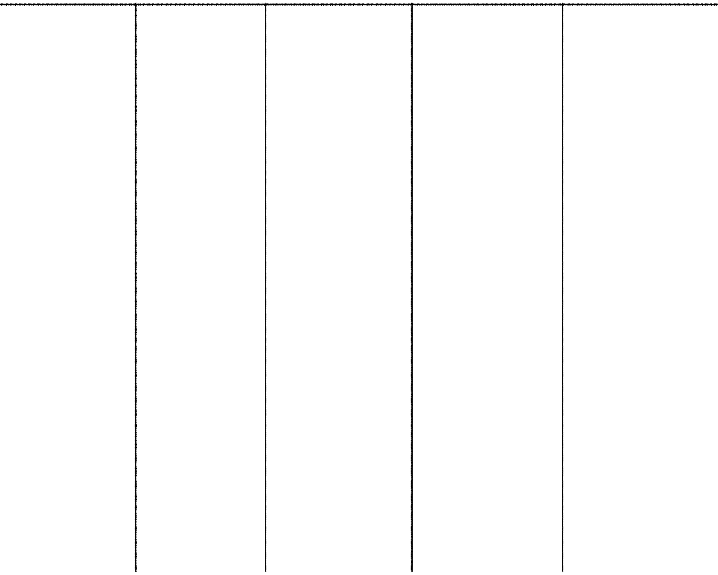

Data

Preparation

8GB,

8GB+RAM,

Intel i3, i3+ processor.

Python, Pandas,

Re, Tensorflow, Keras,

Matplotlib, Seaborn

Data Analysisand

visualization

Data cleaning

and splitting for model

Model

Development

8GB,

8GB+RAM,

Intel i3 , i3+ processor

Python,

Tensorflow, Keras,

Sklearn,

Matplotlib

Machine

Learning, Deep Learning

Model building

Front-Endand

Back-End

4 GB,

4 GB+RAM,

Intel i3 , i3+ processor

Flask, Pickle,

Pandas,

Web

Development.

Website

creation

HTML/CSS,

Bootstrap.

## Design Details

## System Architecture

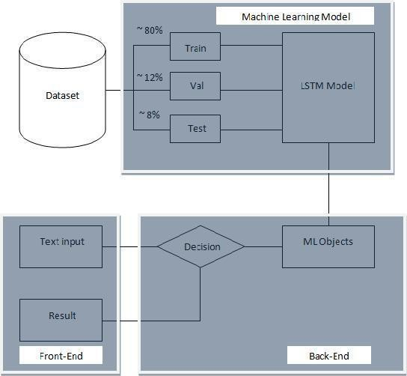

**Fig 3.3.1 Proposed System Architecture**

The basic design we plan on is to give a website to the user where the user can input the textual post or comment or message in an input form. Once the user submits the form the system will run the prediction and detect whether the input is depressive, harassment or neither. The user is then prompted by the system the result of the prediction on a page. The user can go back to the landing page and try different inputs (textual post)

## Detailed flowchart of proposed system

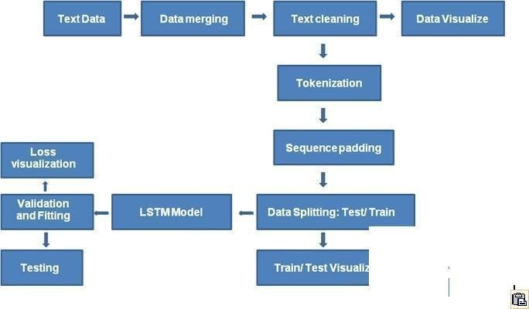

**Fig 3.3.2 Flowchart of proposed system**

Our model basically focuses on detecting depressive and harassment related textual post’s that are shared on social media. A problem with modeling text is that it is messy, and techniques like machine learning algorithms prefer well defined fixed- length inputs and outputs. Machine learning algorithms cannot work with raw text directly; the text must be converted into numbers. Specifically, vectors of numbers. This model comprises of techniques like Bag of Words. The bag-of-words model is a simplifying representation used in natural language processing and information retrieval (IR). In this model, a text (such as a sentence or a document) is represented as the bag (multiset) of its words, disregarding grammar and even word order but keeping multiplicity.

Hence we first read the data that is available to us in the csv files. We load data from those multiple csv files. Then we perform data merging to create a single dataset on which we then perform cleaning. We then visualize the dataset distribution and perform tokenization to represent text data for the model in form of numbers. Then we perform sequence padding and then we split the data into 3 sets. We then visualize the distribution of these 3 sets and check if it’s similar to the

original distribution. Then we train the lstm model and visualize the train and validation result

## Methodology

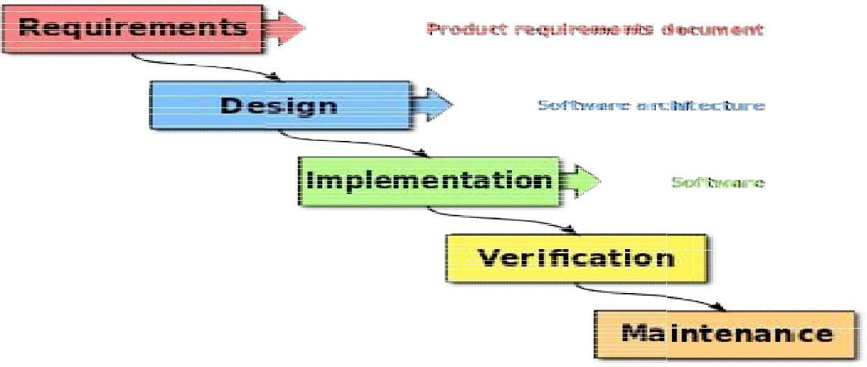

**Fig 3.4.1 Flow of Waterfall Mod[8]**

The waterfall model is a breakup of mission tasks into linear sequential stages, where each step depends on the previous one's deliverables and leads to a task specialization. In other aspects of computer design the approach is common. This appears to be among th e most iterative and scalable methods in software development, as change moves overwhelmingly in one direction ("downwards" like a waterfall) through the various and essential phases of creation, introduction, analysis, planning, building, testing, delivery and maintenance. The waterfall architecture paradigm emerged in the auto motive and building industries; where the tightly organized physical structures meant that improvements in nature had been prohibitively costly in the production process even earlier. There were no recognised substitutes for knowledge-b ased artistic research when first implemented for software development.

11

# CHAPTER 4

**Implementation Details**

## Training Classification Model

#### 4.1.1 Preparing Dataset

Twint is an innovative Python-written Twitter scraping application that helps you to retrieve Tweets from Twitter accounts by utilizing Twitter's API. We used twint library to retrieve the depression and harassment dataset based on keywords and hashtags that reflect depression and

harassment. Other than twint we have used sentiment 140 dataset and toxic comment

dataset to collect positive, negative and toxic comments to add to our dataset. The labels we

have annoted are 0 for non harassment and non depression in the respective models and 1 for depression or harassment in the respective models. We have done sampling of these kaggle datasets and our fetched datasets to achieve adistribution.

#### 4.1.2 Data Cleaning

Data cleaning is an essential tool for Data and NLP research. Text cleaning involves eliminating stopwords (words that don't make much of a difference to the model) and these are usually pronouns, conjuctions etc. In addition to that code cleaning in NLP involves deleting unique characters such as @, # and trailing. Stemming is translating those terms that are identical to a specific root word so model will apply to all those cases where similar words are used, function better, and therefore minimize difficulty.

#### 4.1.3 Tokenization

Tokenisation is a more sophisticated form of information management that can suit and exchange different text documents. It could be the right option for large projects. The Tokenizer must be built to fit into either raw text or encoded text documents in an integer. Next is sequencing and sequence padding where we transform the tokens into sequences used for a sequential pattern. These sequences that vary in duration, so we pad certain sequences to get all the statements or sequences to a standard length.

#### 4.1.4 LSTM

Recurrent Neural Networks (RNN) is a neural network that takes inputs from previous phases and

uses output as a next move. Long term memory (LSTM) modules are the building blocks for the layers of a recurrent neural network (RNN). Standard neural networks can't remember previous experiments and records. LSTM solves this problem. It uses previous results to make smarter choices, in comparison to the present data. The LSTM configuration contains a node, an input wall, an output wall, and a lock. To make more rational decisions, the cell is storing knowledge over broad periods.

## Back-end Implementation

We used Flask Web Framework to develop our Hyper Text Transfer Protocol (HTTP)

Server. This server is used to provide the following services:

To provide a website for the user to access and To Accept text from the users to predict

## Front-end Implementation

The front end is a Web App which consists of the following modules:

The home page acts as the landing page where the user comes when visiting our site. It has some information about what is depression and what is harassment. The about page contains information about the team that developed the system. The check page is the main core part of the front-end. It is the page where the user will enter the text on which detection/ classification is to be performed. It contains the form throught which the user will enter data.

13

## Snapshot

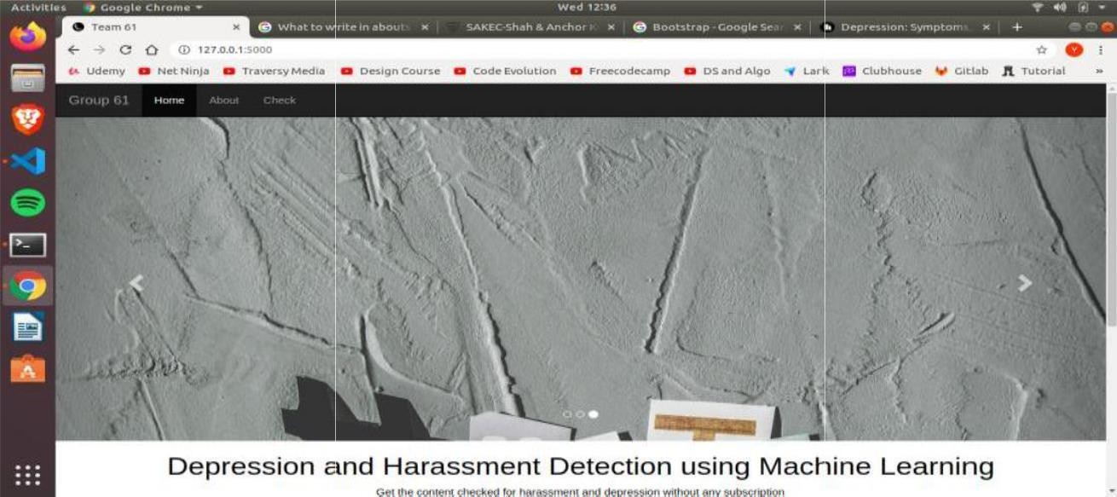

**Fig 4.4.1 Home Page Header**

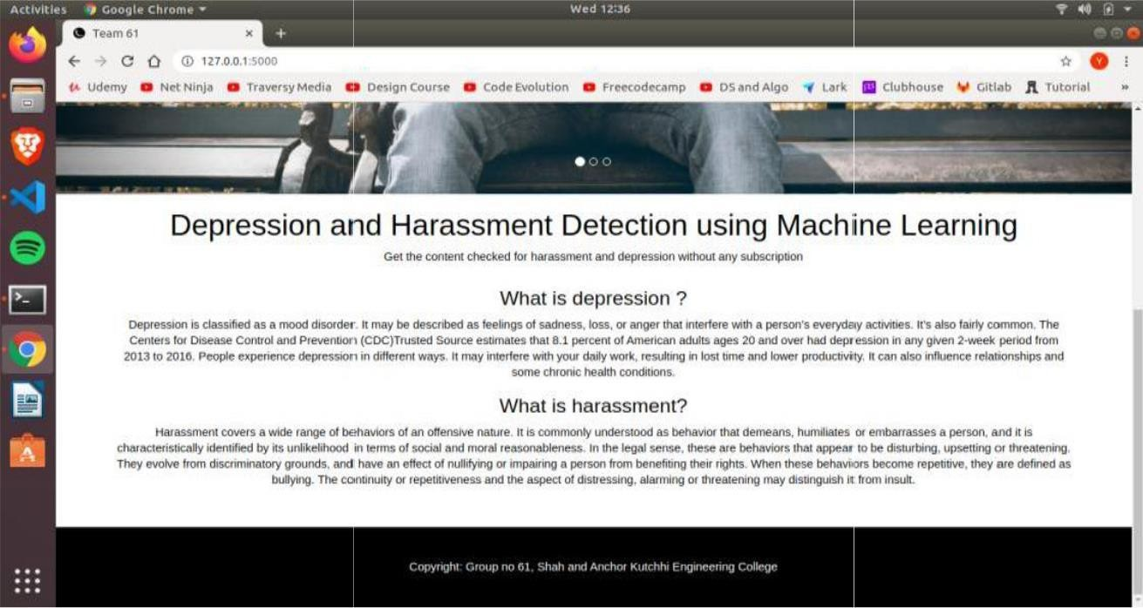

**Fig 4.4.2 Home Page Footer**

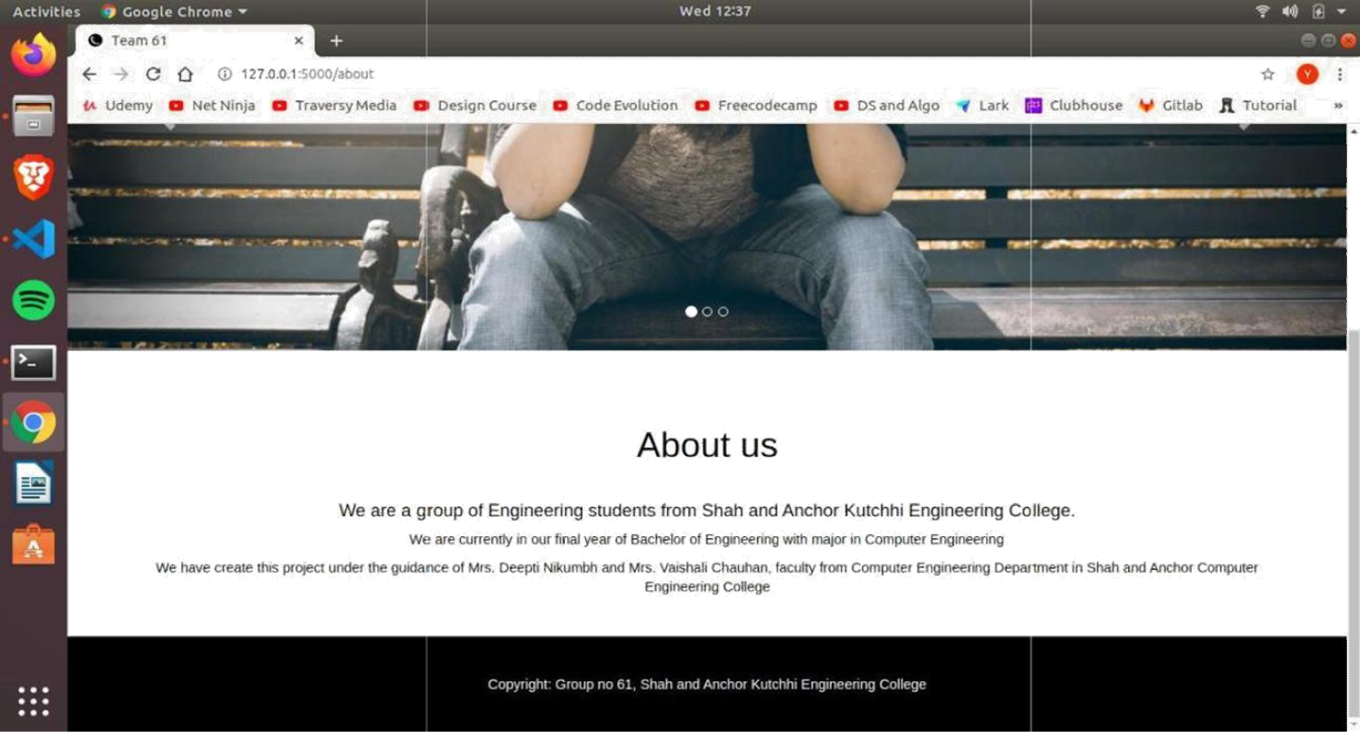

**Fig 4.4.3 About Page**

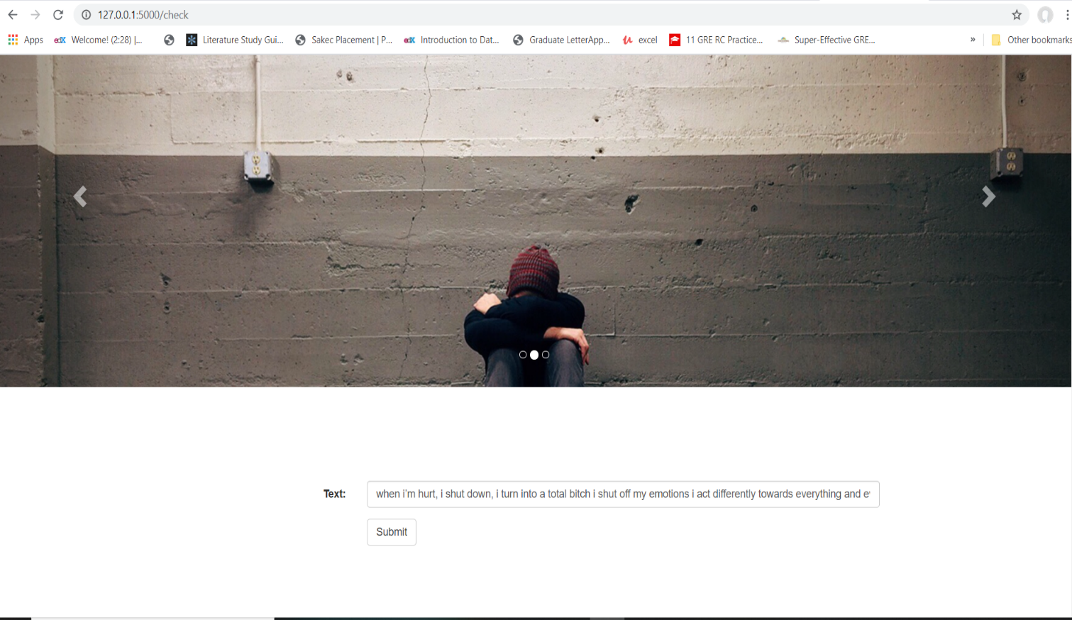

**Fig 4.4.4 Check Page**

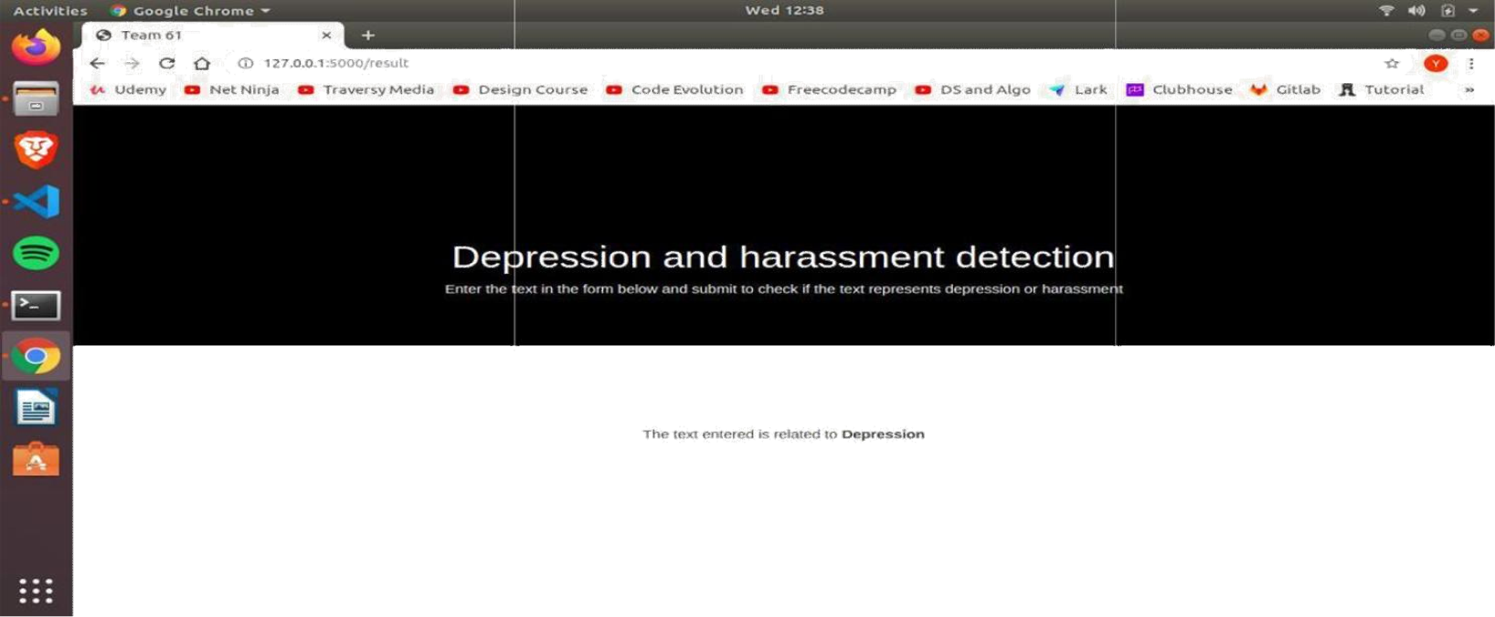

**Fig 4.4.5 Result Page**

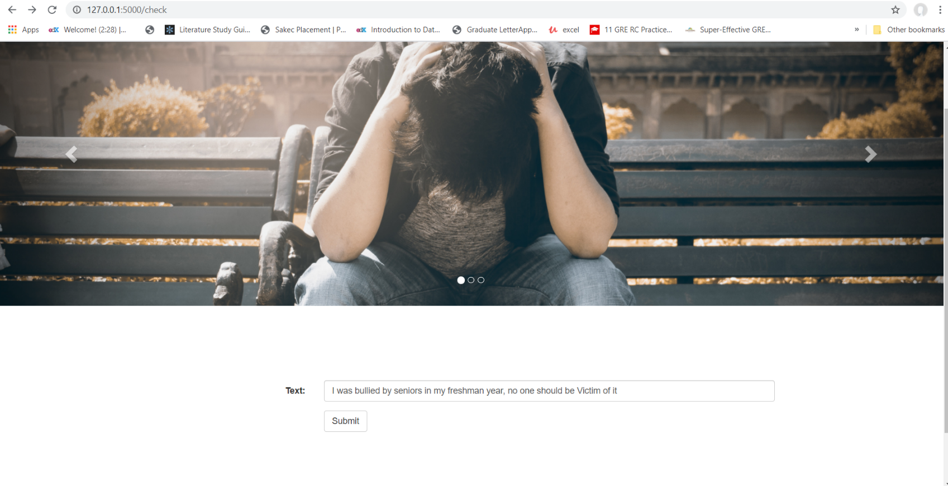

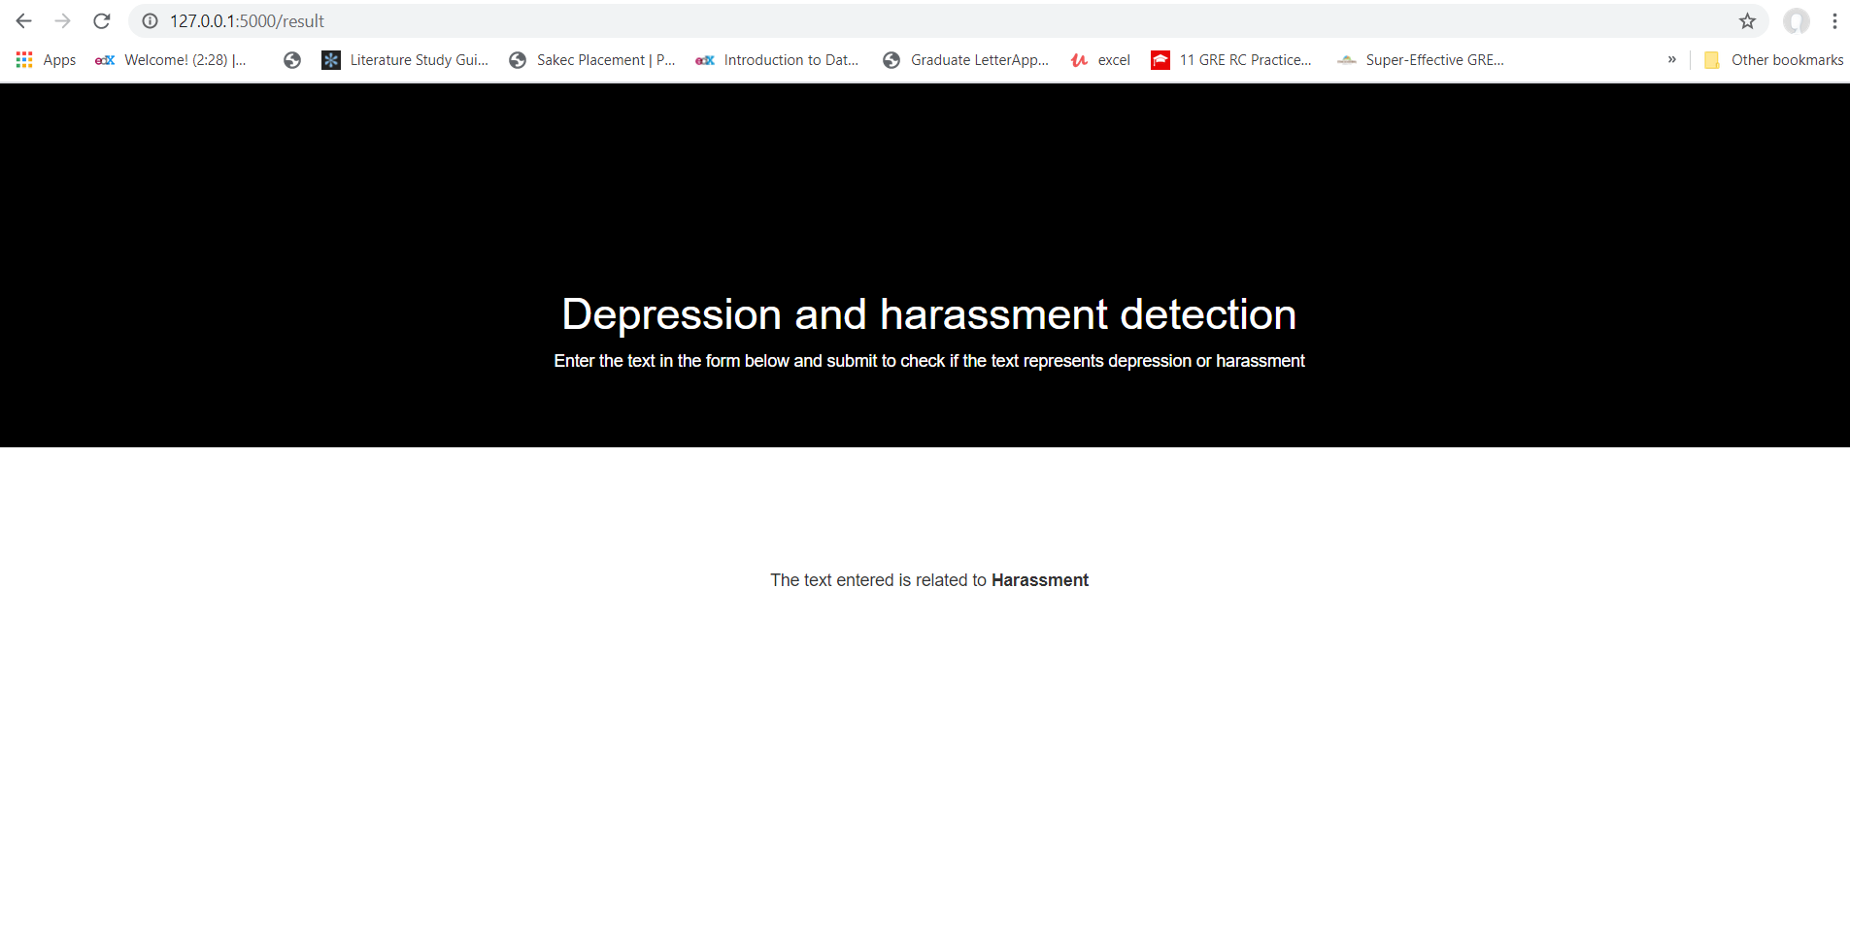

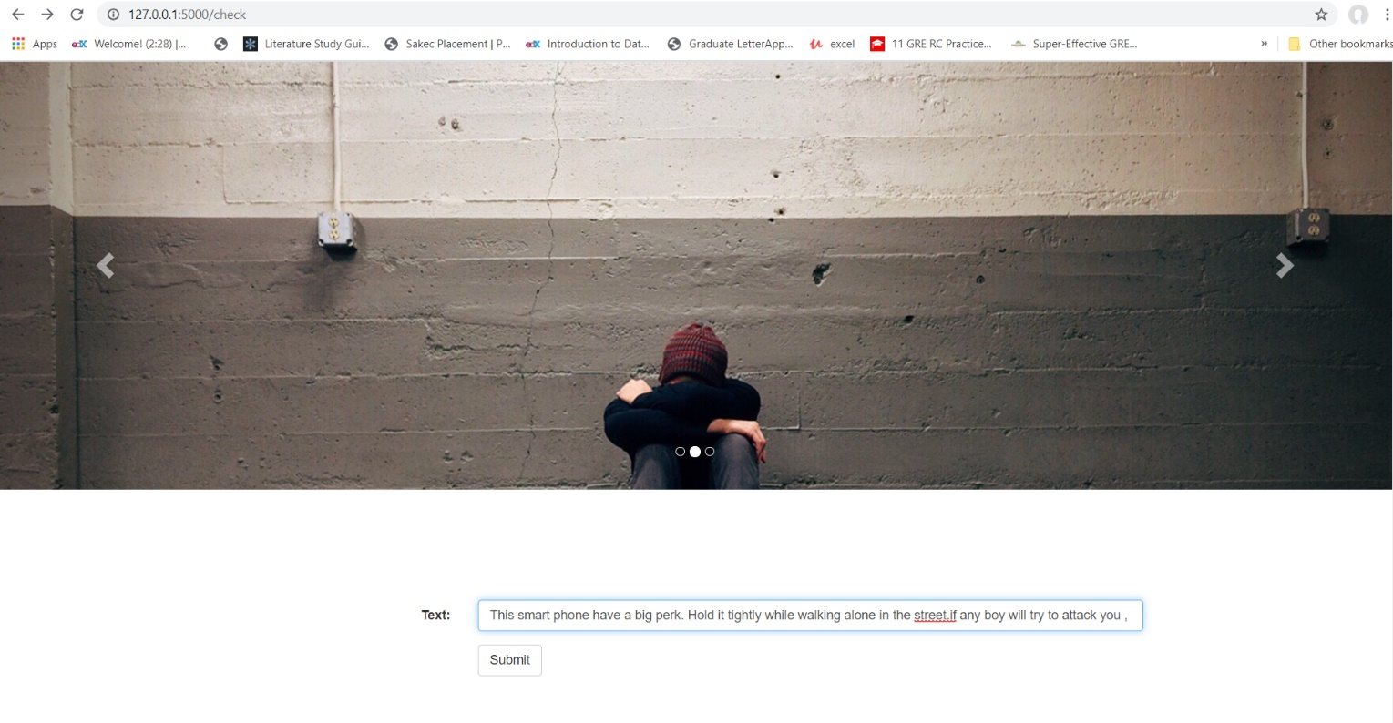

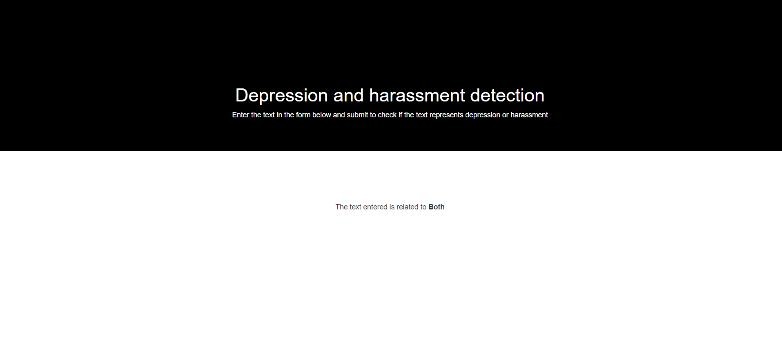

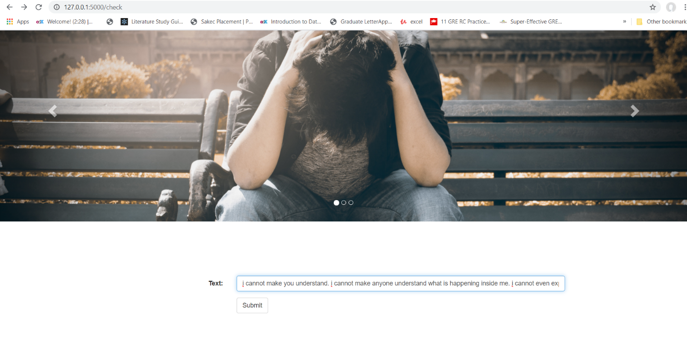

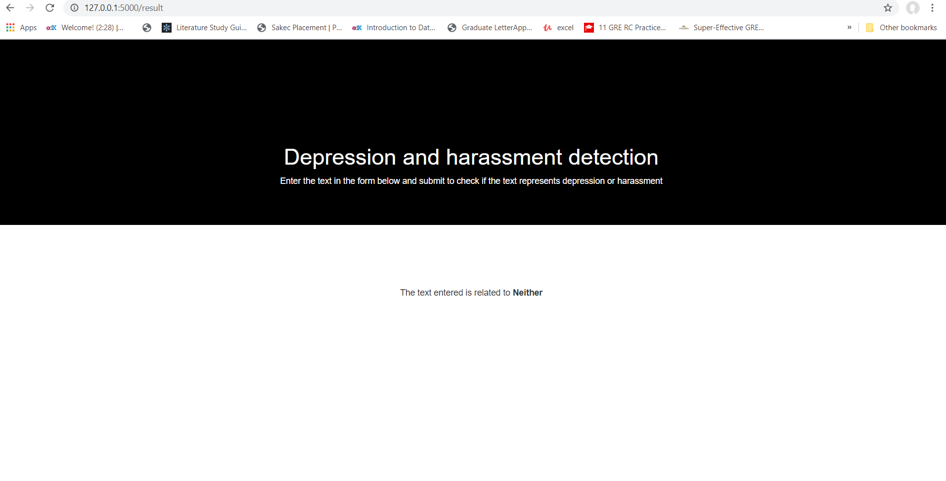

# CHAPTER 5

**Testing**

**Table 5.1 Development of Test cases (Functional)**

Test Objective Steps / Input Expected Actual Result Remark CaseID Description Output Output



IC01 To test the Pass the Social Numberized Vector Pass Successfully preprocessing text to media vector of prepared data

Of data Cleaning and text numbers Tokenization

And Padding

IC02 To test for Pass dataset Dataset Balanced Balance Pass Successfull

Data set plot dataset

Balanced to test for

distribution seaborn data

of dataset countplot balance

IC03 To test the Pass the Splitted 3 balanced Balance Pass Successfull

dataset countplot data for

train/test/ Train/ all3 test for

validation test/ sets. similar distribution Validatio distributio

n to n insplit

countplot

IC04 To test the Passloss of Train Loss Pass No overfit condition trainand and Plot with Value No

foroverfit/ validaton val loss s are underfit underfit forplot loss values close

road

.

IC05 To test the Passthe Testset Veryclose Accuray Pass The modelis

98.0% generalized

detection Test set Accuracyto

accuracyon to 98%

Test set classifier classifier

AP01 To test the Userwill Local hos Landing Landing Pass Allpage

turlof page Pages loaded webpage andall

pages of Enter the

website local host url

and Otherpages

when

requested

other pages when requested

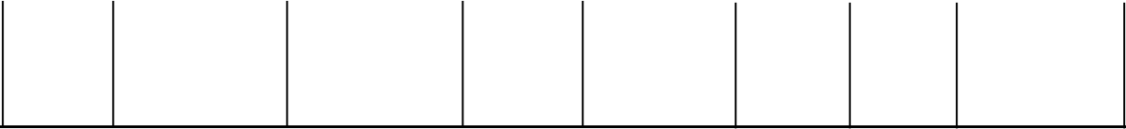

AP02

Test the working of prediction

Enter the text Text to

to check in form and submit

classify

Prediction page with result

Predictio Pass n

Sucessfully predicted

# CHAPTER 6

**Result and Analysis**

We have used the model to predict different textual data to check whether the text belongs to depression or harassment. The result of training the models are :

For Depression:

Table 6.1 Results of depression model

|  |  |  |  |
| --- | --- | --- | --- |
| **Model** | **Training Accuracy** | **Validation Accuracy** | **Testing Accuracy** |
| LSTM | 98.00 | 98.00 | 98.05 |

For Harassment:

Table 6.2 Results of depression model

|  |  |  |  |
| --- | --- | --- | --- |
| **Model** | **Training Accuracy** | **Validation Accuracy** | **Testing Accuracy** |
| LSTM | 97.00 | 97.32 | 97.30 |

# CHAPTER 7

**Conclusion**

We have completed challenges listed in depression and harassment detection on textual data on implementing, developing and testing the system on various inputs. The system performance is found to be significant in determining the type of text entered whether it belongs to class depression or class harassment or neither. We were able to show by implementing the system on real time data and under real time circumstances that technology can help solve this problem and give an early indication of depression and harassment.

# References

[1]. Kantinee Katchapakirin, Konlakorn Wongpatikaseree, Panida Yomaboot, Yongyos Kaewpitakkun, ” Facebook Social Media for Depression Detection in the Thai Community”, 2018 15th International Joint Conference on Computer Science and Software Engineering (JCSSE).

[2]. Tolba Marwa, Ouadfel Salima, Meshoul Souham, “Deep learning for online harassment detection in tweets”, 2018 3rd International Conference on Pattern Analysis and Intelligent Systems

(PAIS).

[3]. [Monirah A. Al-Ajlan ,](https://ieeexplore.ieee.org/author/37086578908) [Mourad Ykhlef,](https://ieeexplore.ieee.org/author/38568413800) “Optimized Twitter Cyberbullying Detection based on Deep Learning”, 2018 21st Saudi Computer Society National Computer Conference(NCC).

[4]. [Qing Cong ;](https://ieeexplore.ieee.org/author/37086604920) [Zhiyong Feng ;](https://ieeexplore.ieee.org/author/37278815200) [Fang Li ;](https://ieeexplore.ieee.org/author/37086418029) [Yang Xiang ;](https://ieeexplore.ieee.org/author/37086421748) [Guozheng Rao ;](https://ieeexplore.ieee.org/author/37267304300) [Cui Tao](https://ieeexplore.ieee.org/author/37086304665) “X-A-BiLSTM:

a Deep Learning Approach For Depression Detection in Imbalanced Data.” [2018 IEEE International Conference on Bioinformatics and Biomedicine (BIBM)](https://ieeexplore.ieee.org/xpl/conhome/8609864/proceeding)

[5]. [Daphney-Stavroula Zois ;](https://ieeexplore.ieee.org/author/38243456100)[Angeliki Kapodistria ;](https://ieeexplore.ieee.org/author/37086453476)[Mengfan Yao ;](https://ieeexplore.ieee.org/author/37086263485)[Charalampos Chelmis](https://ieeexplore.ieee.org/author/37680934400) “Optimal Online Cyberbullying Detection”, 2018 IEEE International Conference on Acoustics, Speech and Signal Processing (ICASSP).

[6]. <https://en.wikipedia.org/wiki/Long_short-term_memory>

[7].Architecture of LSTM [Online]. [Available:https://www.superdatascience.com/blogs/recurrent-neural-networks-rnn-lstm-practical-intuition/](https://www.superdatascience.com/blogs/recurrent-neural-networks-rnn-lstm-practical-intuition/)

[8]. Flow of Waterfall Model [Online]. [Available:https://en.wikipedia.org/wiki/Waterfall_model.](https://en.wikipedia.org/wiki/Waterfall_model)

[9]. Sentiment140 Dataset [Online]. Available: <https://www.kaggle.com/kazanova/sentiment140>

[10].Toxic Comment Classification Dataset [Online].Available: [https://www.kaggle.com/c/jigsaw](https://www.kaggle.com/c/jigsaw-toxic-comment-classification-challenge)- [toxic-comment-classification-challenge](https://www.kaggle.com/c/jigsaw-toxic-comment-classification-challenge)

21

# Publications

A conference paper of this project titled “Depression and Harassment Detection on Social Media using Machine Learning Approach” was presented in International E-Conference on “Industry 4.0:Future Perspective and Agility(ICIFPA 2020)” during 29th-30th May, 2020 held by Sandip University, Nashik. The paper is published in JICR journal, Volume XII, Issue VIII, August-2020 and is available in link below:

ISSN no: 0022-1945/[http://jicrjournal.com](http://jicrjournal.com/)

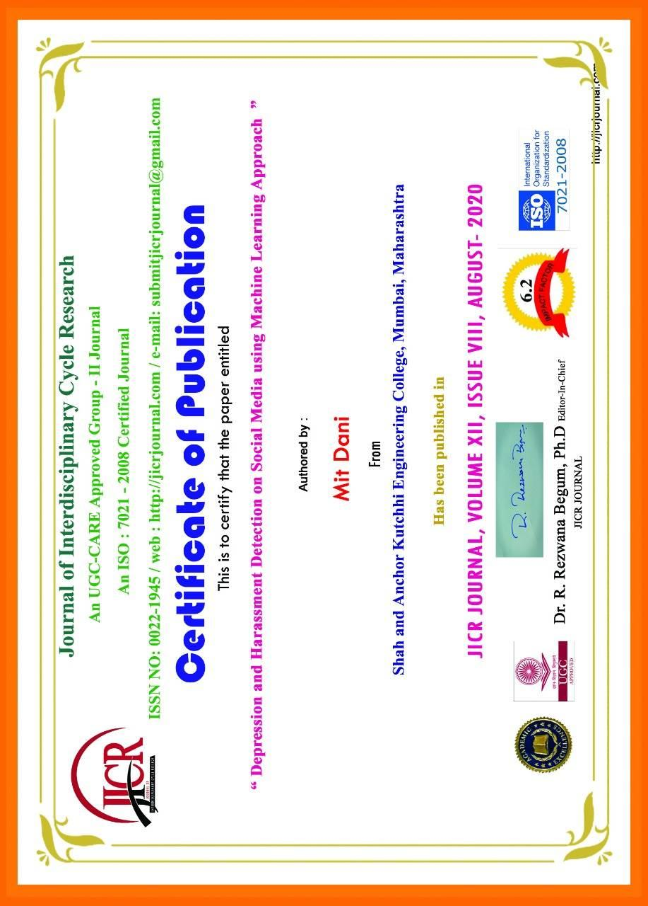

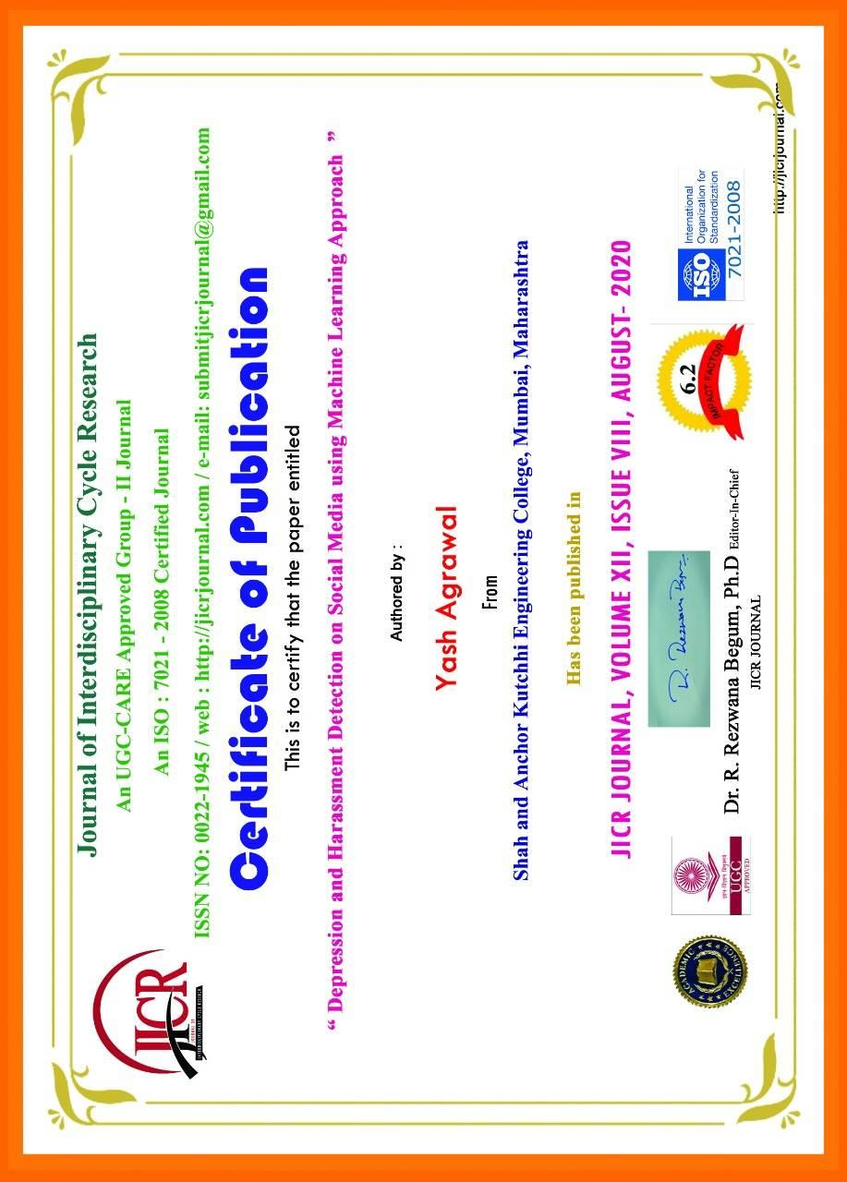

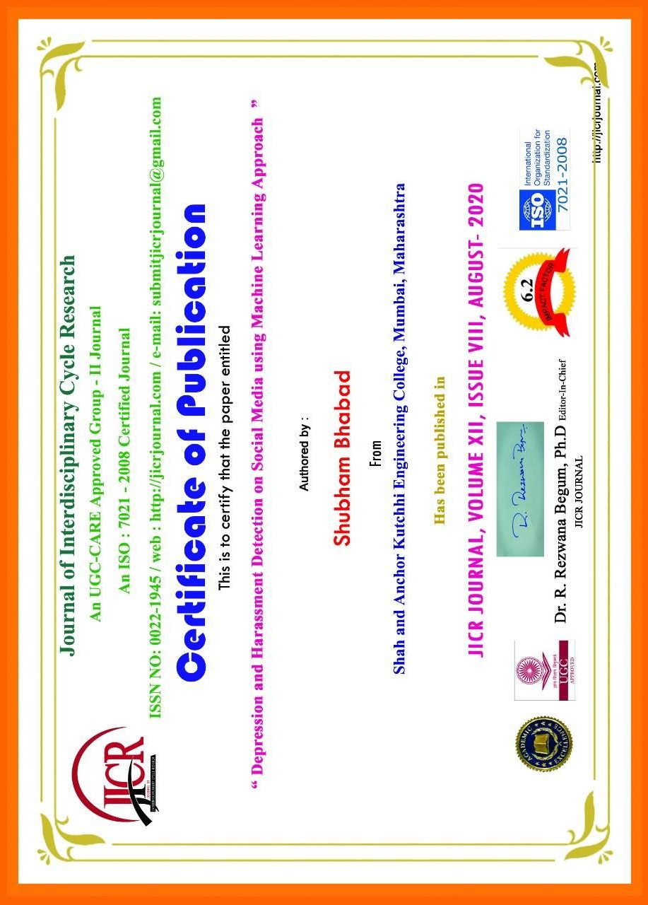

# 

# 

# 

27

# 

28

# 

29

# Plagiarism Report

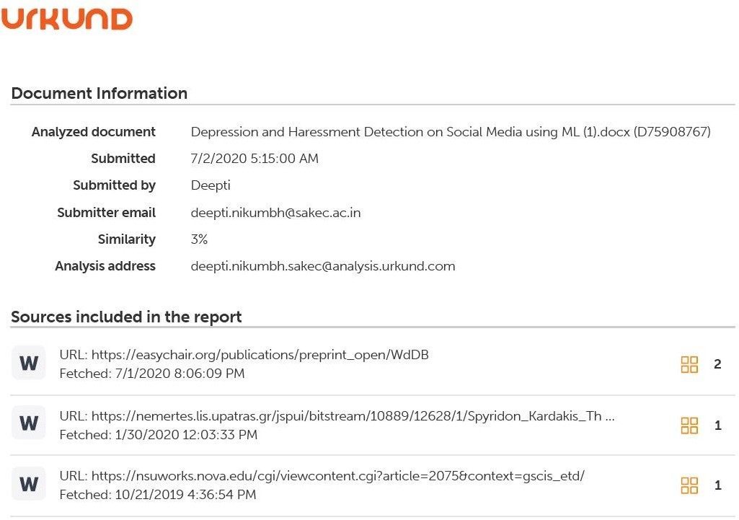

**Research Paper Plagiarism Report**

30

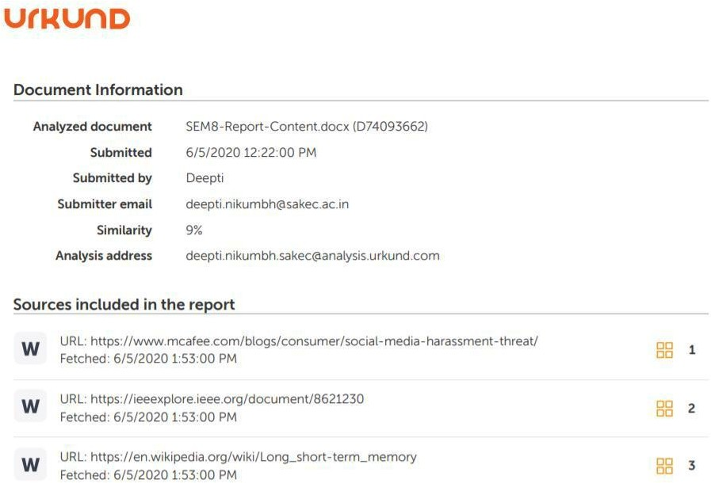

**Black book Plagiarism Report**